2024 Field Day of the Past
Celebrate Independence
July 6, 2024
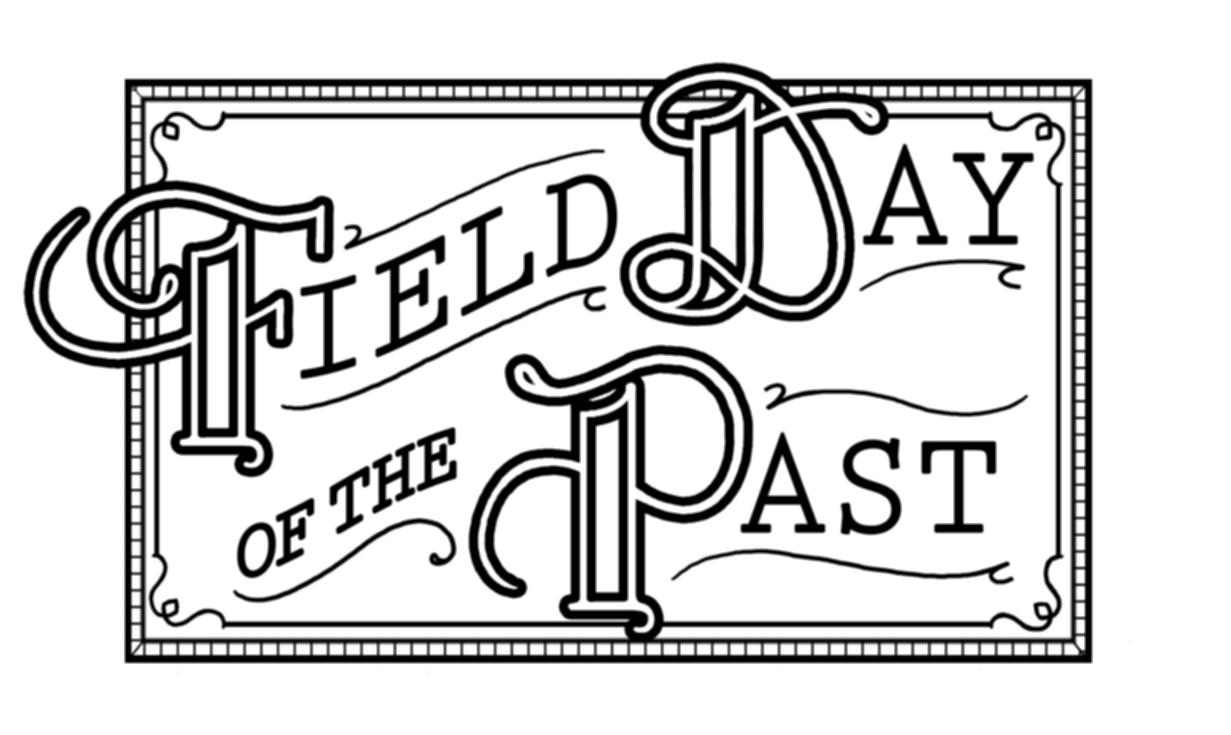

Vendor Guidelines

- No abusive behavior or vulgar language will be tolerated at any time during this event. Anyone in violation of this will be asked to leave immediately and will not be allowed to return at any time in the future.
- No items prohibited for sale by the Commonwealth of Virginia will be allowed, i.e.., guns, brass knuckles, etc.
- You MUST keep your merchandise and all belongings within your allotted space
- NO FOOD WILL BE SOLD IN THESE SPACES.
- The cost for space rental includes a 20’x 20’ space only. Vendor must provide their own tables, chairs, etc. No electricity is available.
- You may set up your booth beginning at noon on Friday, July
- 5. You will be provided access to the grounds at 6 a.m. on Saturday, July 6. Gates will close at 2 p.m. after which time, admission will be charged to get through the gates. You are welcome to keep your booth open for the afternoon/night activities.
- Field Day of the Past reserves the right to deny any vendor from participating based on subject matter
which are not in keeping with the Field Day of the Past image will not be allowed.
- No space will be reserved without receiving payment. All application requests for space must be accompanied by payment.
- No alcohol is allowed to be brought onto the grounds at any time. Coolers may be checked after 2 p.m.
- Guidelines may be changed as needed and will take precedent over the existing guidelines.

These guidelines have been established in an attempt to provide both our vendors and those attending a pleasant and fun experience. We appreciate your adhering to all guidelines. By signing the Booth Space application you are agreeing to these guidelines.

